1. 
2. Attach to this lecture, you will find this Sample Angular App.
3. 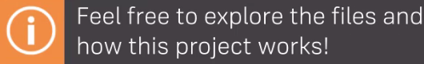
4. Skipped after this last slide.